**ASSIGNMENT 2**

**Registration Screen, Password Strength & Session Storage**

**Assignment Objectives :**

* **HTML5 features (Email, telephone)**
* **HTML5 features (progress bar)**

**Application :** <http://cmpe280-assignment2.s3-website-us-east-1.amazonaws.com/>

**1. Registration Screen**

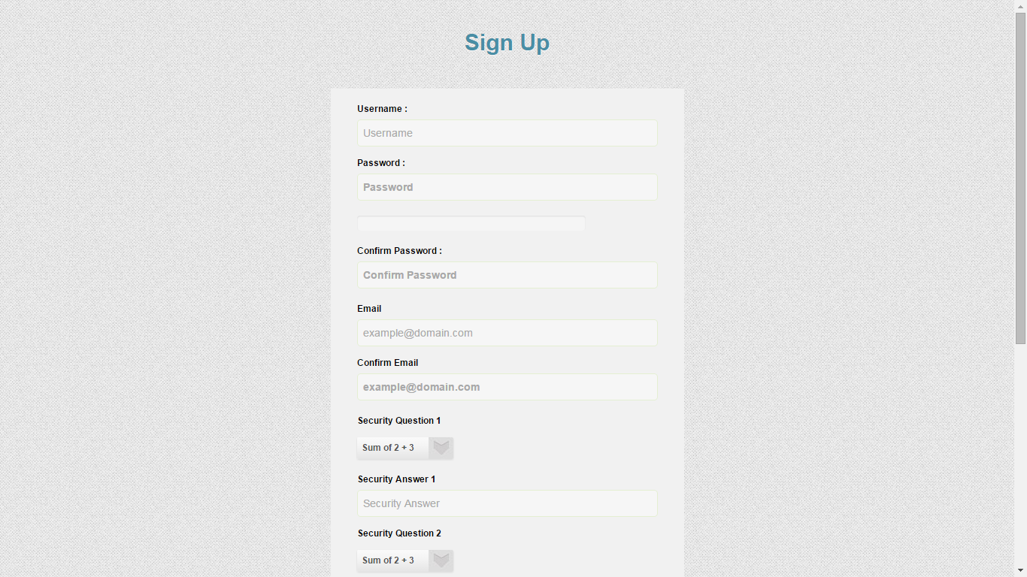

**2. Password strength ( progress bar)**

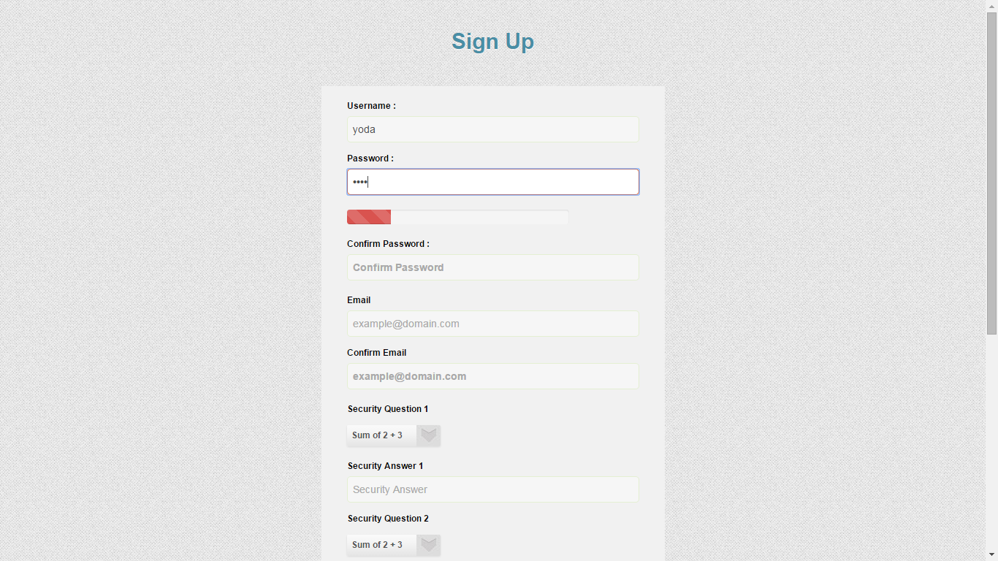

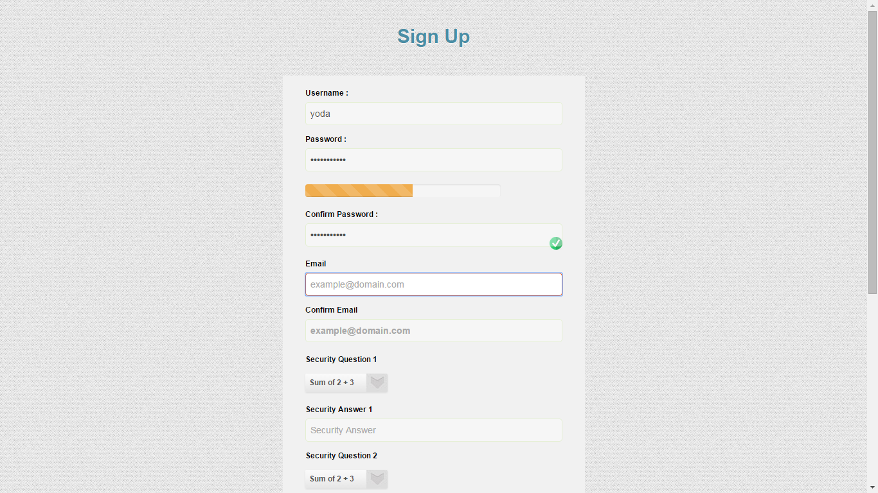

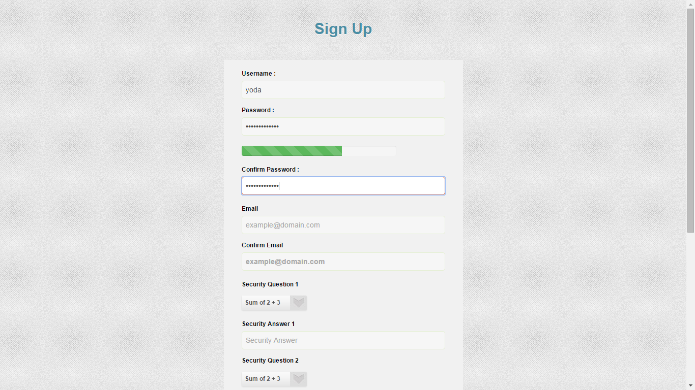

**3. Password match, E-Mail Match and Phone number validation (custom validations)**

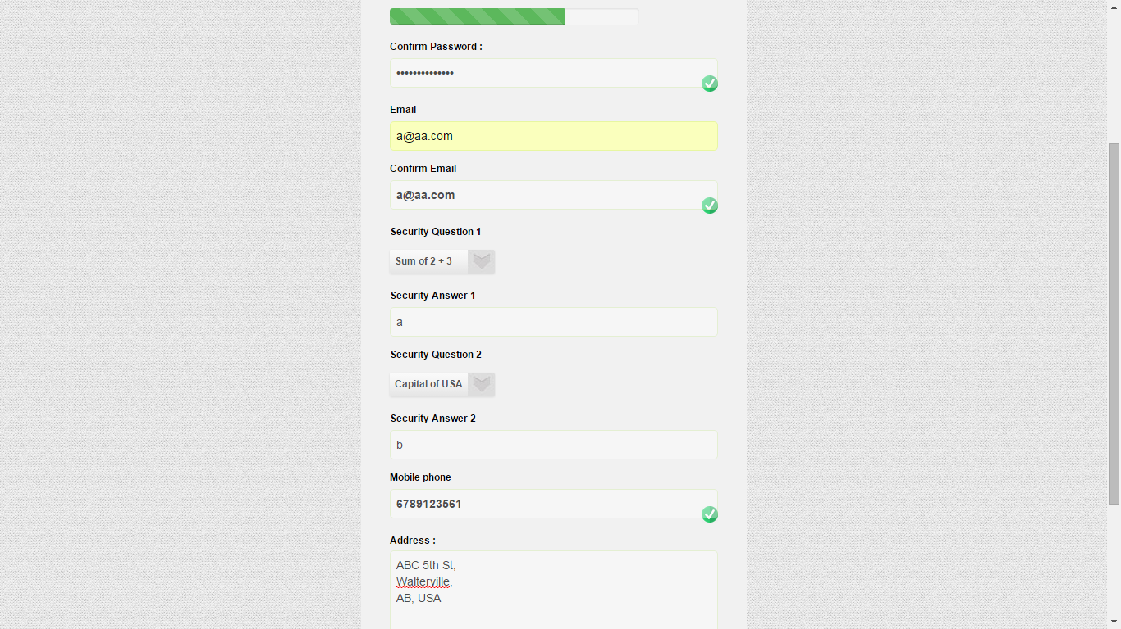

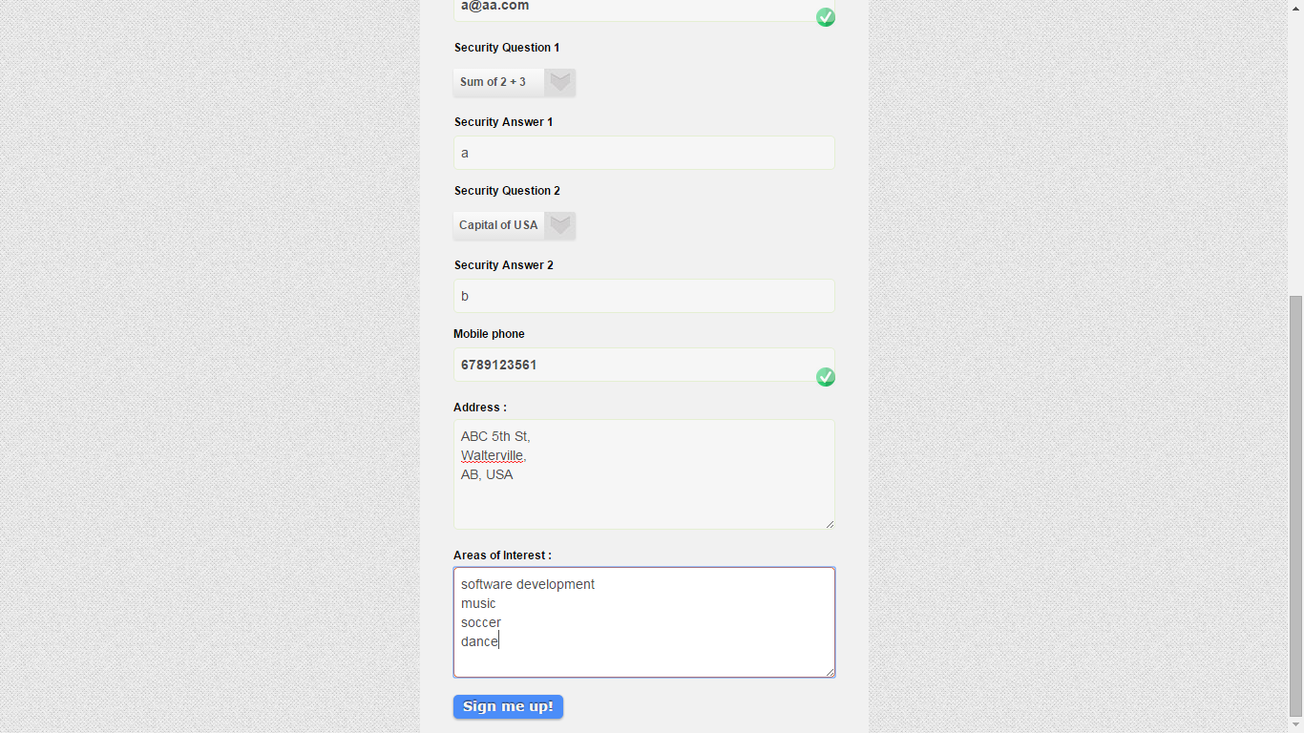

**4. Registration successful data saved in session storage**

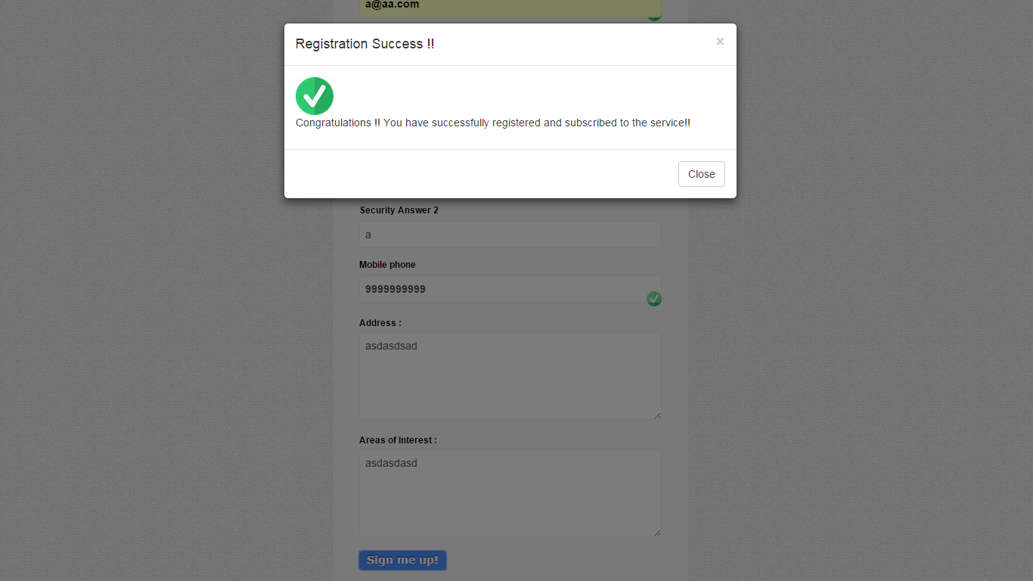

**5. Registration failure**

